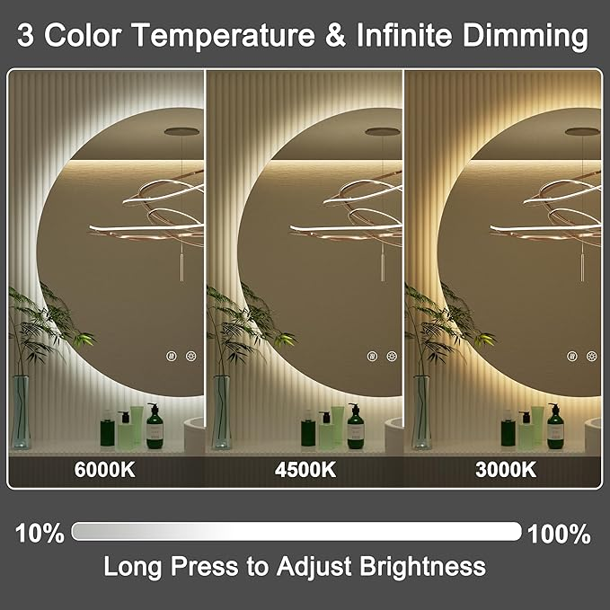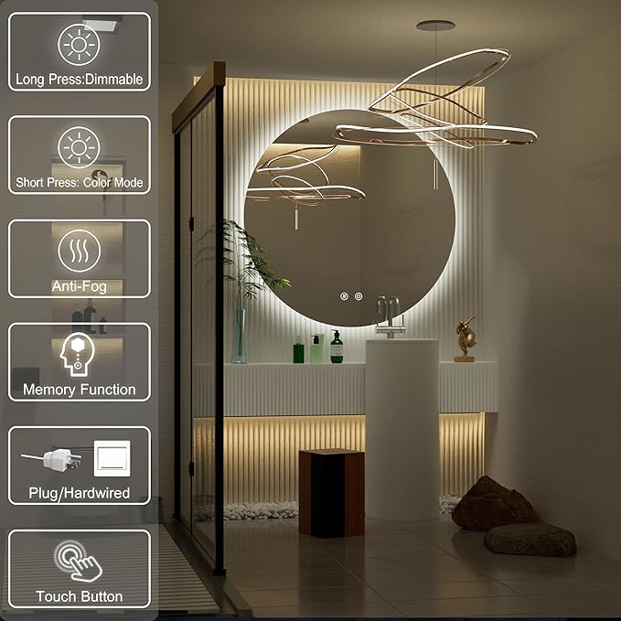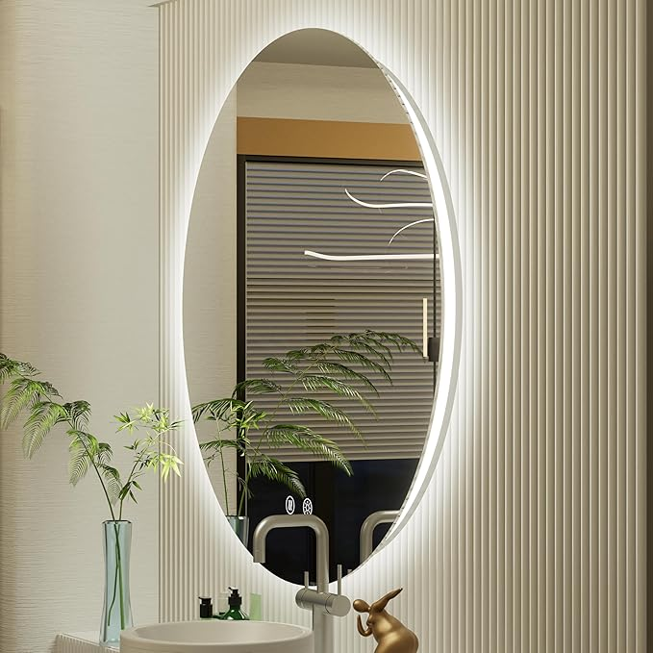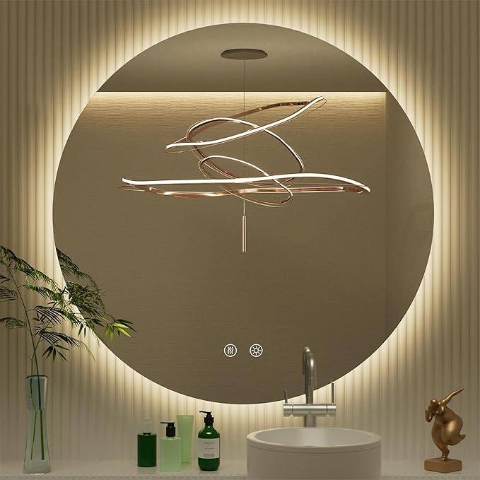

32 Inch Round LED Mirror for Bathroom, Backlit Vanity Round Bathroom Mirror with Lights, LED Lighted, Dimmable, Anti-Fog, Touch, 3000K/4500K/6000K

**PRODUCT DESCRIPTION:**

|  |  |
| --- | --- |
| Brand | JSneijder |
| Room Type | Bathroom, Dressing Room, Bedroom, Living Room, Hallway |
| Shape | Round |
| Product Dimensions | 32"L x 32"W |
| Frame Material | Unframed |

**About this item**

* [ Sleek Design ] Our round LED mirror features a frameless design that seamlessly integrates into any bathroom decor, providing a modern touch to your space with its elegant round shape
* [ Adjustable Brightness ] The LED bathroom mirror comes with adjustable brightness settings, allowing you to customize the lighting to suit your mood and needs, making it perfect for makeup application or grooming
* [ Anti-Fog Functionality ] Equipped with an anti-fog feature, this round lighted mirror ensures a clear reflection even after a hot shower, enhancing your daily routine without compromising visibility
* [ Energy-Efficient Lighting ] The round LED mirror utilizes energy-efficient LED technology, providing bright illumination while saving on electricity, making it an eco-friendly choice for your bathroom
* [ Versatile Use ] This LED mirror for bathroom use is not only functional but also stylish, making it an ideal addition to bathroom, cloakroom, dressing room and beauty room alike, adding both utility and elegance to your home
* [ Easy Installation ] Designed for user-friendly setup, our LED bathroom mirror can be easily mounted on your wall, providing both functionality and elegance in your home